MATANUSKA-SUSITNA BOROUGH
ADMINISTRATIVE HEARING AGENDA

Edna DeVries, Mayor  Planning & Land Use Director  Alex Strawn  Planning Department  Admin. Specialist  Lacie Olivieri  Assembly Chambers of the  Dorothy Swanda Jones Building  350 E. Dahlia Avenue, Palmer | 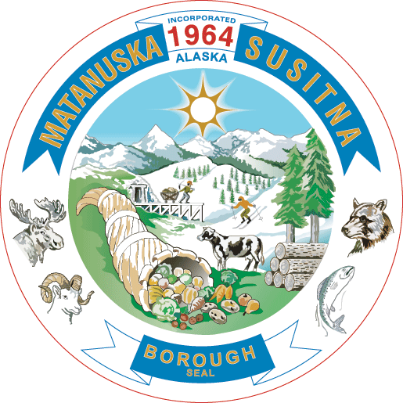 | Michael Brown, Borough Manager  PLANNING & LAND USE DEPARTMENT  Jason Ortiz, Planning and Land Use Deputy Director  Wade Long, Development Services Manager  Fred Wagner, Platting Officer

November 19, 2025
REGULAR MEETING
2:30 P.M.

Ways to participate in the Administrative Permit meetings:

IN-PERSON: You will have 3 minutes to present your oral comment.

IN WRITING: You can submit written comments to the Planning Department Admin. at planning@matsugov.us.

TELEPHONIC TESTIMONY:
- Dial 1-855-290-3803; you will hear “Joining conference” when you are admitted to the meeting.
- You will be automatically muted and able to listen to the meeting.
- When the Chair announces audience participation or a public hearing you would like to speak to, press *3; you will hear, “Your hand has been raised.”
- When it is your turn to testify, you will hear, “Your line has been unmuted.”
- State your name for the record, spell your last name, and provide your testimony.

I. PLEDGE OF ALLEGIANCE

II. PUBLIC HEARING

An Administrative Permit In Accordance With MSB 17.67 – Tall Structures Including Telecommunication Facilities, Wind Energy Conversion Systems, and Other Tall Structures, For A Cell Tower Located at 3600 E. Bogard Road, Tax ID# 2327B01L004. (Applicant: Justin Abbott, on behalf of AT&T Mobility; Staff: Rebecca Skjothaug, Current Planner)

III. ADJOURNMENT

Disabled persons needing reasonable accommodation in order to participate at a Planning Commission Meeting should contact the Borough ADA Coordinator at 861-8432 at least one week in advance of the meeting.

